LIABILITY INSURANCE - Each Renter must hold liability insurance and list CMWRC in its policy. Information detailed in APPENDIX 1.

BACKGROUND CHECK / SP-167 - All teachers and administrative staff in the facility must have a background check completed and submitted to CMWRC. (County DSS rules for working with children). CMWRC to maintain a comprehensive list of employees and people in the facility at any given time. Renters must provide list of staff, contact and email. Information detailed out in APPENDIX 1

ONLY AUTHORIZED INSTRUCTORS ALLOWED - From time to time custodians will perform random checks to verify name of instructors / administrators.

FIRE ARM POLICY - No fire arms / gun arms in the facility. Concealed or otherwise.

CHECK-IN / CHECK-OUT - Renters will be allowed 15 minutes before the set time and must vacate within 15 minutes after end time of the rental. Renters will be required to check in and check out - listing room numbers occupied and time in use.

SHOES ONLY IN THE CUBBY - Please ensure all shoes are placed only in the cubby’s in the shoe room.

NO FOOD OR DRINKS IN CLASS ROOMS - No food or drinks on the lower level except in the conference room which also serves as a break room.

WAITING IN THE LOBBY - Parents and siblings must wait in the front lobby and all kids - especially young ones must be attended to at all times. Parents and siblings in the lower level is disruptive to classes in session.

CAR PARKING/STANDING/WAITING AT FIRE LANE IN FRONT OF THE BUILDING - Parent's cannot line up in front of the mission for pickups. This is a violation of county's fire safety rules and causes a traffic situation. Please adhere to the fire safety rules and not risk anyone's life/safety. We have ample parking spaces – instruct parents to take that time to park properly in the parking lot and come in to pick up their child from inside the Mission.

MINDFUL USAGE AND CLEANLINESS – Instructors and Administrators are accountable for room cleanliness. Pencil and Pencil lead shavings on the floor that leave the carpets permanently damaged can be avoided by appropriate instructions and constant reminders to students. Trash and tissues not in the trash bin, items left behind by students and in general displacement of tables / chairs – should be attended to before concluding the rental. Most times there is another class which will follow before the cleaning schedule. Leave the room as you would like to enter into.

DROP OFF AND PICK UP OF CHILDREN – For the safety of the children attending the CSLC classes offered by the vendors, we would like the vendors to instruct the parents that the child must be left in the care of the authorized teacher and not just dropped off at the facility. CMWRC will not be responsible for any child that is simply dropped off at the facility and not handed over in care of the authorized teacher. Similarly child has to be picked up from inside the facility and not from the curb.

APPENDIX 1

Insurance requirements:

- Every CSLC program provider will be required to carry and furnish a Liability Insurance with the following specifics.

CSLC program providers are required to furnish proof of liability insurance coverage with minimum policy limits of $1,000,000 for all activities. Such proof of liability is required prior to approval of the long term use agreement and shall name Chinmaya Mission Washington Regional Center (CMWRC) as an additional insured party to the policy. A hard copy of the certificate shall be provided by the provider to Chinmaya Somnath office prior to any use of the facility. CSLC Program providers are required to provide an updated insurance certificate prior to its expiration.
Note that this inclusion of CMWRC and the policy itself is to remain effective for the entire year unlike a inclusion just for an event.

Here are few vendors who have named Chinmaya Mission in their policies for events/ short term rentals held at the facility and could assist with an annual policy.
Note: "The insurance Company/Agency name/s provided below is NOT an endorsement or recommendation from CMWRC. There are multiple Insurance Companies and Agencies in the market. You may choose any of them as you deem appropriate.”

1.KEENER INSURANCE AGENCY (571)490-7903

2.EAST MAIN STREET INSRUANCE (WILL MADDUX) 530-477-6521 INFO@THEEVENTHELPER.COM

3.American Speciality INSRUANCE amerspec.com 800.245.2744

4.Audrey Lamontagne 860-583-0943 alamontagne@starshelp.com

5.https://www.theeventhelper.com/
The policy should look like below, also shown an inclusion of CMWRC for an existing policy.
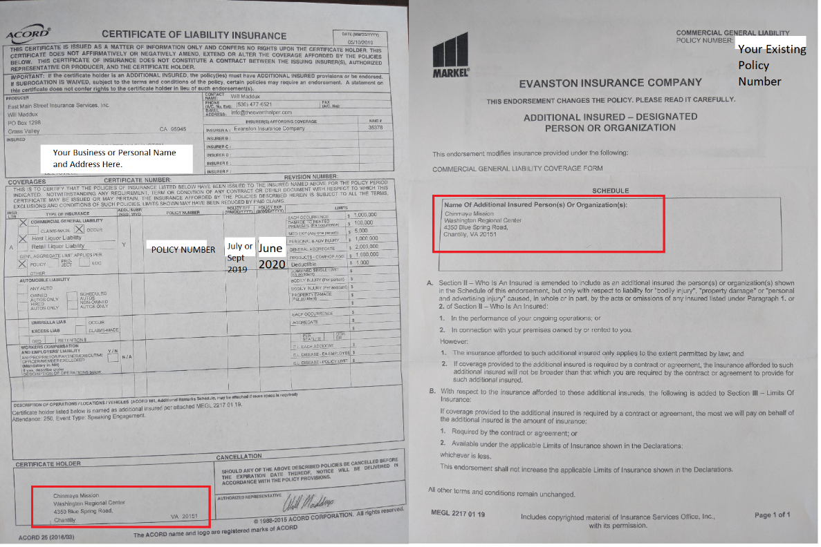

APPENDIX 2
Background Check for ALL Teachers AND Administrative staff in the Mission:
All teachers and administrative staff associated with the CSLC provider and working with children in the facility will be required to furnish a background check certificate to the Chinmaya Somnath office. This is a Virginia Department of Social Services (DSS) guideline that Chinmaya Somnath is mandated to strictly adhere to.
This is a fairly simple process and costs only $20 per person and lasts for a year. Please follow along specifics
Visit the below site.
http://www.vsp.virginia.gov/CJIS_Criminal_Record_Check.shtm
Click on SP-167 Link shown below. Information MUST be entered online and past completion the form needs to be printed for notarized signatures and eventual submission to Chinmaya Somnath. The form has a 'Confirm" button at the end of the form. Please verify all the information twice for accuracy before pressing the 'confirm' button. One cannot edit any information past the confirm button is pressed.
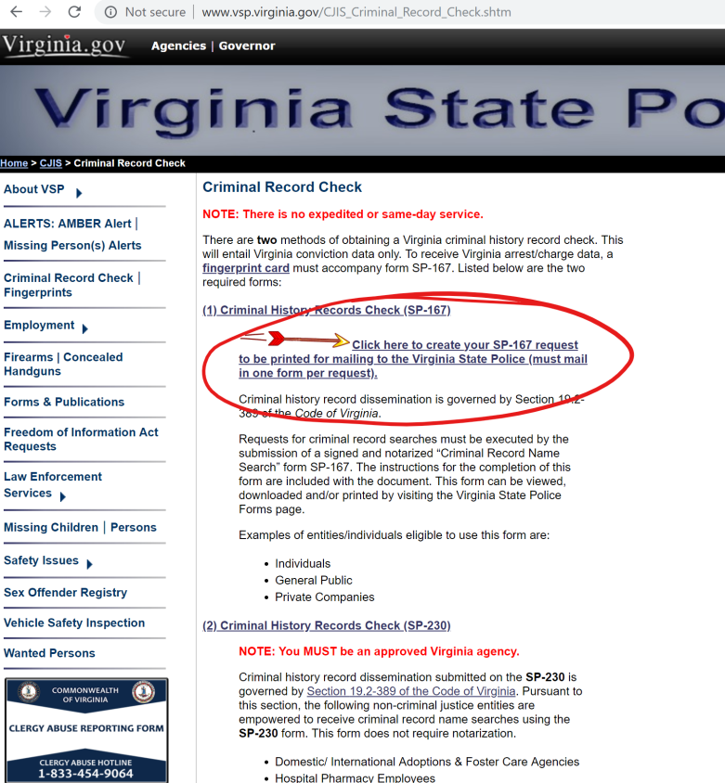

Here’s what the online form looks like and note the information that needs to be checked and entered.
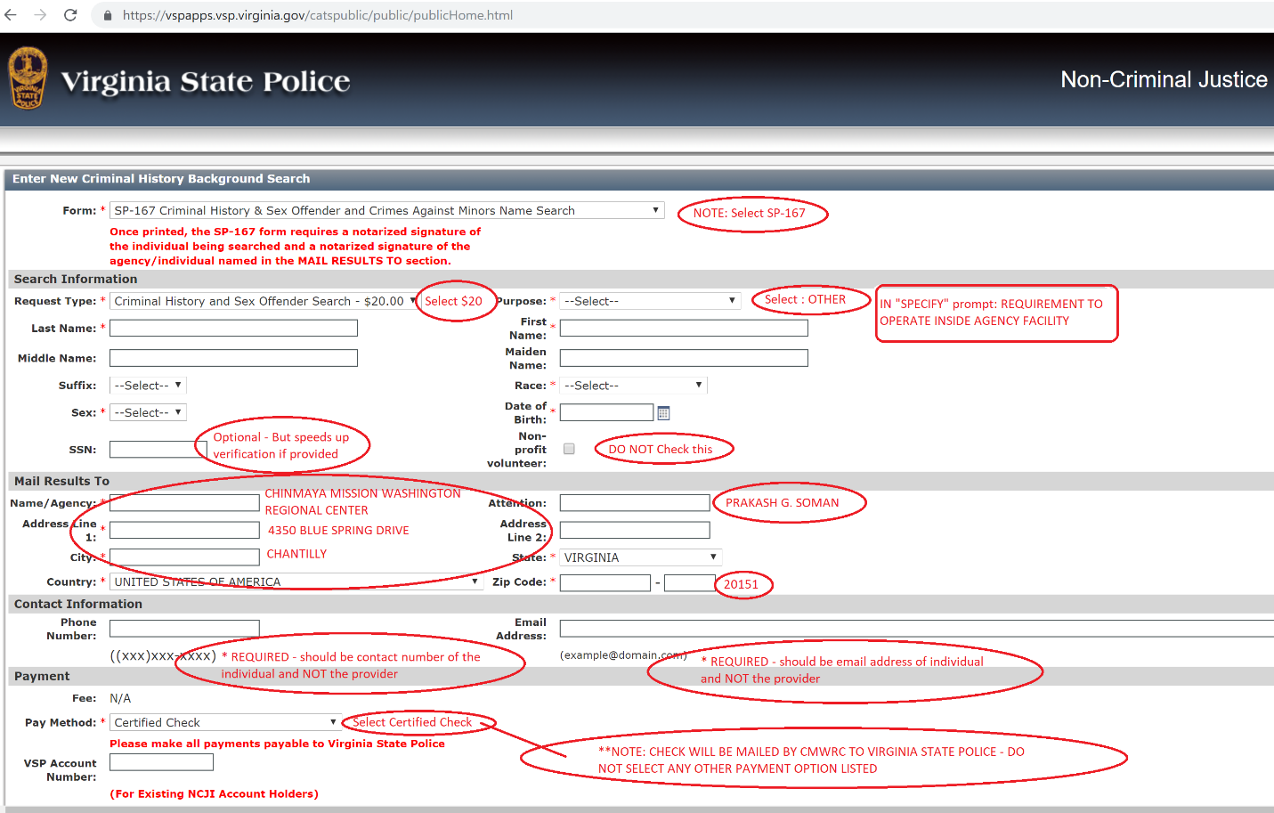

Once completed – and the “confirm” button has been clicked – there will be one more prompt before the document SP167.pdf is automatically downloaded on your machine. This will probably be in the “Download” folder. Most times the PDF will automatically open in the browser or Adobe Reader – but sometimes it won’t. The Printed form will look like below. Note that the printed form has a unique bar code specific to that application. Enter one form per individual.
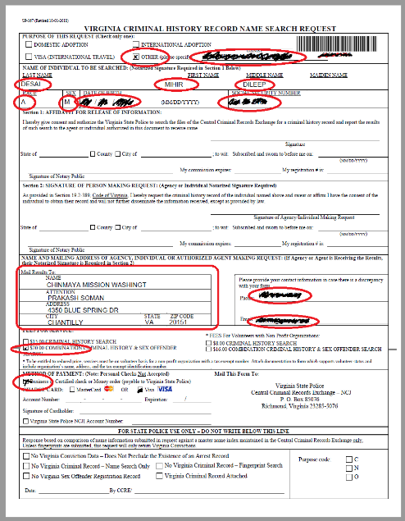

Once printed please get your signature Notarized. This is the highlighted section. Sign only in the presence of a Notary – and the remaining information will be entered by the Notary including date. Usually the bank which you operate with provide this service free of charge. Alternatively most UPS stores offer this service for a fee.
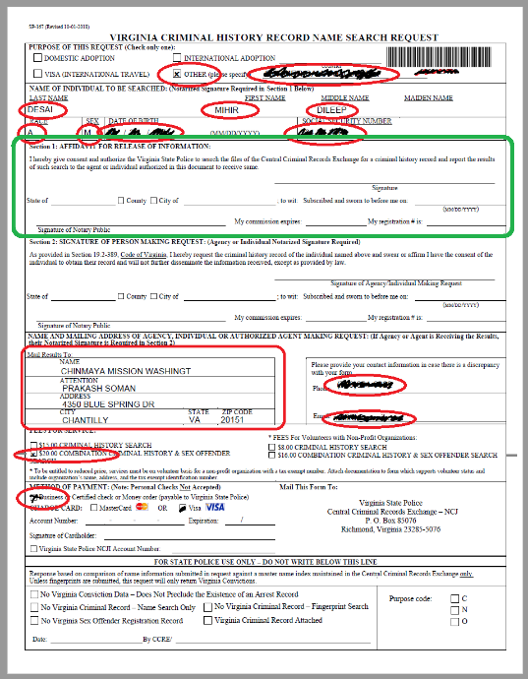

Upon completion – please submit this form to Chinmaya Somnath Center either directly to Prakash G. Soman or with one of the CSLC operations team member along with $20 Check drawn in favor of CMWRC. Prakash Ji then will collect these forms and needs to get his signature notarized in the Agency section. CMWRC requires 5 business days to consolidate forms and get everything notarized before mailing them out – so please account for that time as well.
Once completed – CMWRC will draw a certified check and send it to Virginia State Police. As stated Virginia State Police takes up to two business weeks to review and approve these background checks. Individuals will be notified (provided email / phone number) upon successful response back from Virginia State Police. Providers and the approved individuals can begin operating inside the Mission ONLY after this response has been received back. Please plan accordingly to ensure everything is in place well before setting dates for your offerings at Chinmaya Somnath.

Additional Information Re: Background Checks:
Please find attached additional information citing requirements by DSS that Chinmaya Somnath is adhering to. Note that SP-167 does not require finger printing and is more accessible than the required standards for teachers who work with kids in Chinmaya Blossoms.

